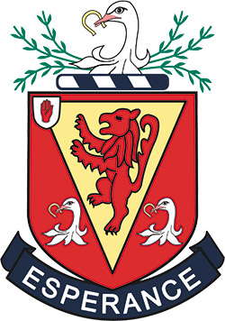
WALLACE HIGH SCHOOL
School Council

In Wallace High School the school council is a formal group of pupils who are elected by their peers to represent them and their views at council meetings.
The school council provides a meaningful way in which pupils can voice their opinions and have their views taken into account in decisions which impact upon them. It also provides leadership and development opportunities for pupils.
Structure
Two pupils are elected at the start of the academic year from each class to represent their class at Year Group council meetings. Two of these representatives are nominated to serve as Chairperson and Secretary, and sit on the Executive Committee which meets with Senior Management over the course of the year to report back on issues discussed.

The agenda for each meeting covers 3 items:

- A school issue
- A Form issue
- A pupil issue

Minutes of the meeting are forwarded to the VP (Pastoral) and can help formulate the agenda for Executive Council meetings.

There is a total of 6 meetings scheduled for the year which are coordinated by the Assistant Head of Year and VP (Pastoral).

We believe the work of the school council compliments our Citizenship classes and the many leadership opportunities in school; we are confident that our young people are equipped for a role in the wider world.

