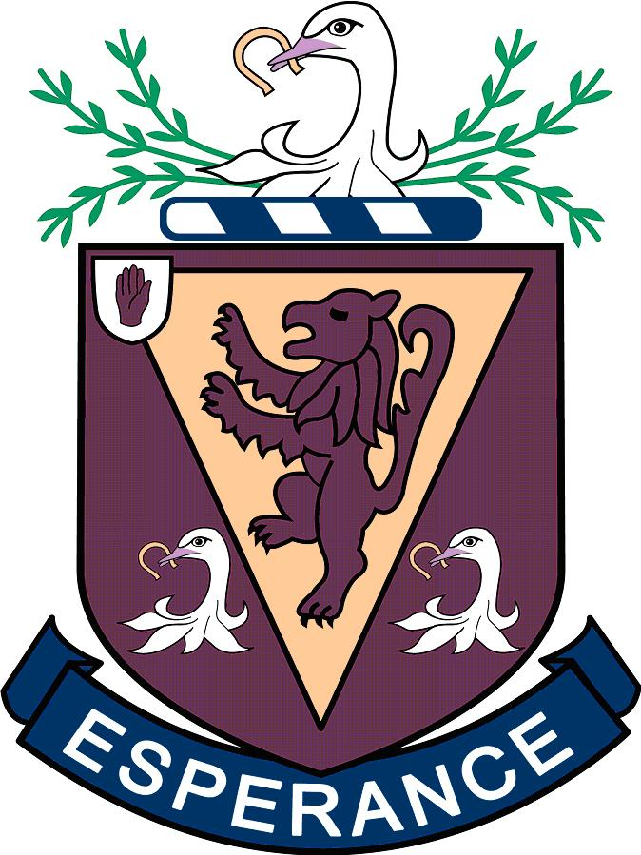

CEIAG POLICY

Preparing for Success
The Careers Education, Information, Advice and Guidance Strategy (CEIAG) and Implementation Plan, was published jointly by the Department of Education (DE) and the Department for Employment and Learning (DEL) in January 2009. Its aim is “to develop effective career decision makers leading to increased and appropriate participation in education, training and employment” and to support DE’s Revised Curriculum including the Entitlement Framework policies and DEL’s Success through Skills – The Skills Strategy for Northern Ireland.
The strategy’s implementation plan has been developed around 5 key themes which are:
- Improving careers education;
- Improving access to careers information;
- Improving careers advice and guidance;
- Improving quality;
- Improving professional development.

This Policy reflects the 5 core area of CEIAG Learning Entitlement.

Delivery of CEIAG

Careers Education
Careers Education - Timetabled KS3

A structured careers education programme is provided in years 8 to 10 as part of the Employability strand of LLW which covers the statutory requirements of :-

- Local and Global Economy
- Enterprise and Entrepreneurship
- Careers Management/career exploration
- Employability key elements are addressed within Areas of Learning and as part of Careers across the Curriculum and have been mapped.

The programme is underpinned by a structured progressive Personal Career Planning process which is meaningful to pupils learning and decision making. This includes:

- Self-assessment /self-awareness
- Target setting, action planning , research and review
- Pupil records maintained
- Links are made as appropriate to the student’s Progress File
- Direct relevance to progression and future employment of individual curricular subject’s is identified via collapsed timetabled presentations

Careers Education - Timetabled KS4

A structured careers education programme is provided in years 11 to 12 as part of the Employability strand of LLW which covers the statutory requirements :-

- Timetabled lessons are provided over the 2 year period (see statutory requirements KS4 Appendix 3 and audit - Appendix 4)
- Pupils are supported in making informed personal choices re: Post 16 options
- The programme is underpinned by a progressive Personal Career Planning Process
- Links are made as appropriate to the Progress File
- Direct relevance to progression and future employment of individual curricular subject’s is identified via collapsed timetabled presentations

Careers Education - Time-tabled Post -16

A structured careers education programme is provided in years 13 and 14 which supports pupils to establish and follow a Personal Career Plan. In particular it:

- ascertains student’s strengths, weaknesses, interests and values and uses this knowledge to develop and support career choices
- allows students to research HE, FE, training and employment opportunities available to them using a range of sources
- further develops the student’s own decision making skills
- further develops job search skills e.g. interview skills, CV.
- Provides an understanding of and makes best use of the FE and Higher Education application systems including UCAS and CAO)
- Provides access to how students go through the process of Student Finance, Loans and Scholarships.
- Pupil interviews in support of individual research

Careers Advice and Guidance

CEIAG is ongoing throughout the entire time that a student is at Wallace. Even after
students have left, the Head of Careers is available to offer advice and guidance to e.g. students who have decided to change degree options.

Ongoing provision of guidance to individual pupils is provided through:-

- Self-referral interviews
- Parent/pupil interviews at key transition points. Specific presentations are given to Year 10 and 12 pupils and followed up by parent/pupil interviews as part of the GCSE and post 16 choices process.
- DEL Careers Service
- Pupil interviews and follow-up support

This is provided by:-

- The Head of Careers the Deputy Head of Careers and Employability Teachers
- DEL Careers Advisers
- Specialist/subject teachers
- FE and HE Careers Officers
- Sector Skills Councils
- Employers

A Service Level Agreement (SLA) has been agreed with the Careers Service

Careers Information

A Careers Information is readily available, relevant and appropriate to all pupils. This informs pupil’s career planning, potential career pathways and post-16 education, training options and employment options. Provision includes:

- A careers library with job profile fact sheets, guidance materials, books, journals, prospectuses, CD ROMs
- Occupational information available on C2K via JED and interest based research tools using Pathfinder
- Web-based resources using the Northern Ireland Careers Service and Sector Skills Councils web sites
- User- friendly Labour Market Information/ job forecasts via Employability lessons and posters
- External Guest speakers
- Attendance at the annual Regional Careers Convention run by LBEP
- Open day/visits to FE and HE Institutions
- Presentations from a number of universities including Irish institutions.
- Year 10 and 12 option choice collapse time presentations and interviews to include the importance of STEM.
- Post 16 presentation as part of Parents Evening
- Attendance by the Head of Careers at all relevant Parent/pupil information
Evenings
- Presentations and lessons given by departments concerning careers routes related to subject areas.
Work related Learning Experiences

The Department has a coordinated programme of activities which provide opportunities for all pupils to gain an insight into the world of work, both as an integral part of the subjects they are studying as well as stand alone activities which contribute to the overall CEIAG programme. These include:

- Speakers representing occupational sectors.
- Ex-pupils talking about their post school experiences
- Enterprise activities such as Mini Companies / Young Enterprise
- Job search skills – CVs and personal statements

A Register of Employers and speakers has been initiated.

Work experience and Mock interviews

Both events are organised the Deputy Head of Careers.
Work Experience takes place in the Lower Sixth at set time in February over three days. All students are supported in the entire process of choosing their work experience and reviewing it. This provision is supported by bespoke Work Experience Management software.

Mock interviews take place in Upper Sixth.

