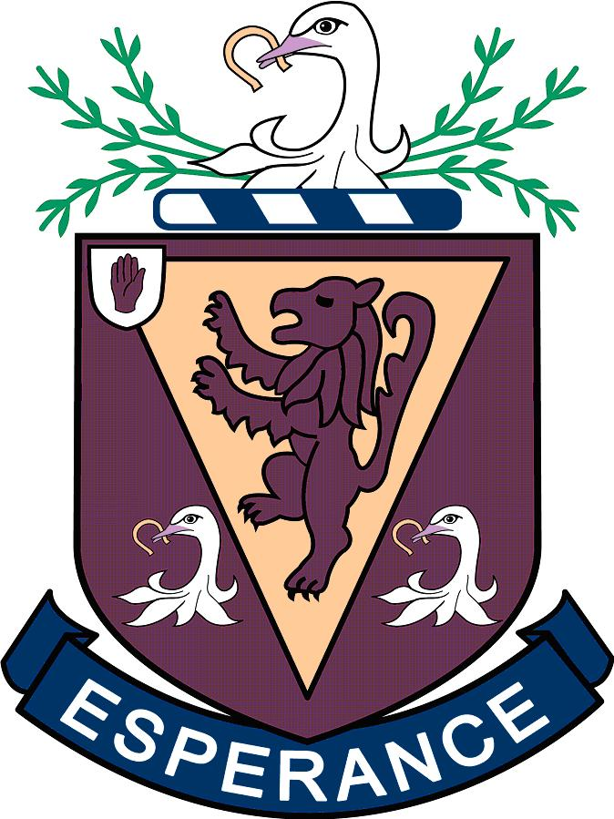

RECOGNISING AND CELEBRATING SPORTING HONOURS

As a school community we aim to celebrate success. Celebrating and recognising the vast array of sporting successes in our school community of almost 1,300 young people is a priority. Not every success can be recognised officially but also quiet words of encouragement, Assembly announcements, letters of congratulations are important and will remain a priority.

1 Representative Honours

Tier Name | Definition | Minimum Criteria | Recognition
1 | Representative Honour in any sport at any age (not a school sport) | Recipient of Honours Award must have had match time on the pitch, court etc. in a competition. Friendly, development fixtures are not deemed a cap. | Name recorded on school website & sports awards booklet along with twitter and Facebook pages. Photograph taken individually for Hall of Fame & Group Photo
2 | Representative Honour in a sport which the school competes at provincial or national level (affiliated sport) | Criteria as 1. Sports currently include: Badminton, Equestrian, Tennis, Judo, Squash, Swimming, Golf. | As 1 plus school honours tie and representative sport pin
3 | Representative Honour in a sport which the school coaches and competes at provincial or national level | Criteria as 1. Sports Include: Athletics, Cricket, Hockey, Netball, Rugby | Same as 1 & 2 plus representative honours badge.
4 | Representative Honour in a sport which the school competes at in the most senior level available for a sport | Criteria as 1 & 3. Only Years 12-14 | As 1 & 2 plus embroidered recognition on blazer pocket. Also name recorded after they leave school before the end of June on the Honours Board in pupils last year Format:  Name, Sport, Level, Years Played
Special | Representative Honour which is Exceptional | Commonwealth/Olympic | Framed Signed Jersey on wall in New Gym Foyer
Post School | Representative Honour at Senior Level | Ulster, Ireland, GB, Commonwealth, Olympic | Framed Signed Jersey on wall in New Gym Foyer
2 Recognising Achievement

Achievement is recognised in two ways:

1 through commitment and sustained effort at the most senior level in a school sport
2 through winning or being runner up in a major school competition

Award | Definition | Minimum Criteria | Recognition
Senior Colours  Year 12-14 | Pupils should have shown commitment and sustained effort to an individual or team school sports most senior team. (Affiliated & Coached) | Have displayed a positive and exemplary attitude towards sport, team members, coaches and staff at all times  Have demonstrated an exceptionally high level of ability, commitment & sportsmanship with due regard to comparative standards  Have given a sustained commitment and been a regular member of appropriate 1st team/squad  Meet any specific criteria set by member of staff in charge of sport and agreed by Sports Award Committee | 1 Achievement recorded on school website, sports Twitter & Facebook.  2 Recorded in Annual Sports Awards Dinner Programme.  3 Presented with Certificate. Senior Colours Sport Tie and Colours badge.
Sporting Achievement  Year 8-14 | Pupils have shown commitment and sustained effort and have achieved outstanding success in a major competition at a school sport | Have demonstrated an exceptionally high level of ability, commitment & sportsmanship with due regard to comparative standards  Have given a sustained commitment and been a regular member of appropriate 1st team/squad  Meet any specific criteria set by member of staff in charge of sport and agreed by Sports Award Committee  Winner or Runner Up only | 1 Achievement recorded on school website, sports twitter & Facebook.  2 Recorded in Annual Sports Awards Dinner Programme.  3 Presented with Certificate & Sports Pin at Sports Awards Dinner.

Sports Awards Process

Sports Awards Committee

Members: The Sports Awards Committee to consist of the Principal, 1 or 2 members of the Leadership Team, the PE Department and members of staff responsible for a particular sport. The quorum for the committee is five.

Chair: Head of PE

Secretary: Principal’s Personal Assistant

Meeting

This meeting will be held to discuss and approve awards. Notice of a Sports Awards Meeting will normally be given at least seven days in advance, although it may also be necessary to call ad hoc meetings e.g. to approve Special Awards. Minutes will be kept of the decisions of the committee.

Communication

Governing bodies do not routinely contact the school to report representative honours. Therefore, parents will be asked to email sporting achievements and representative honours to sportingachievements@wallacehigh.net before 1 April annually. The Sports Awards Committee will meet once these have been collated. Achievements reported after this date will be recorded the following year.

Presentation

Awards presented at Annual Sports Awards in April and name written on Representative Honours Boards by end of June.

Appeals

An appeal against the application of the award should be made to the Chair and the Sports Awards Committee re-convened if required

