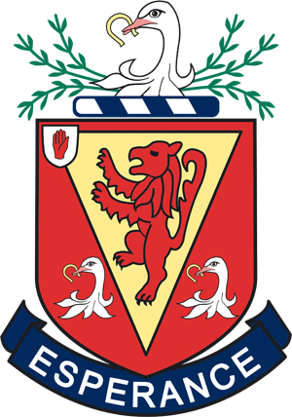
COMPULSORY P.E. CLOTHING AND EQUIPMENT
Some additional branded items are available for Games which can be purchased at Parental discretion.
All of the following items are available from McCalls, Lisburn, Reach E.P.S. Ltd & Warnocks.

BOYS GIRLS
Year 8 Year 8
*Navy polo shirt with red trim & School Crest *Navy polo shirt with red trim & School Crest
*Navy shorts with red trim & School Crest *Wallace skort
*Navy sport leggings with School Crest
*Knee length white socks
Other Years Other Years
Plain navy embroidered polo shirt (PE) Plain white embroidered polo shirt
Plain navy athletics shorts (PE) Navy skort
White ankle socks (PE) Plain navy athletic shorts
Navy reversible rugby shirt with white collar – [Y8 Games] Knee length white socks
Plain navy rugby shorts (Games) Wallace High School Tracksuit
Knee length red socks (Games)
Wallace High School Tracksuit
Rugby Rugby [Boys]
Years 9 & 10 Year 11 & Seniors
Standard reversible navy/grey rugby shirt Reversible navy/grey rugby shirt
Navy rugby shorts Navy rugby shorts
Red knee length socks Navy and white knee length socks
Hockey [Boys] Hockey [Girls]
Years 9 & 10 Years 9 & 10
Navy Kukri top Junior hockey shirt
Navy Kukri shorts Navy Skort
Navy and White knee length socks Red knee length socks

* New style PE Kit introduced 2017 for Year 8. Older pupils replacing kit should buy new style kit but there will be a period of transition.

All students playing extra-curricular sport for school teams are notified of the correct team list. Girls in Year 11 and above who play hockey wear the Senior hockey shirt.

The following items can be purchased from an appropriate retailer:
Laced running shoes Laced running shoes
Rugby or football boots [black] Ankle length white socks
White socks Hockey Stick

All students playing extra curricular sport for school teams are notified of the correct team list.

ALL ITEMS OF CLOTHING AND SPORTS EQUIPMENT MUST BE CLEARLY NAMED

The Physical Education Department recommends that all pupils involved in contact sports should wear a mouth guard which has been correctly fitted. Mouth guards and other protective equipment (eg shin pads, shoulder pads, head guards etc) should conform to British and European Safety Standards.

