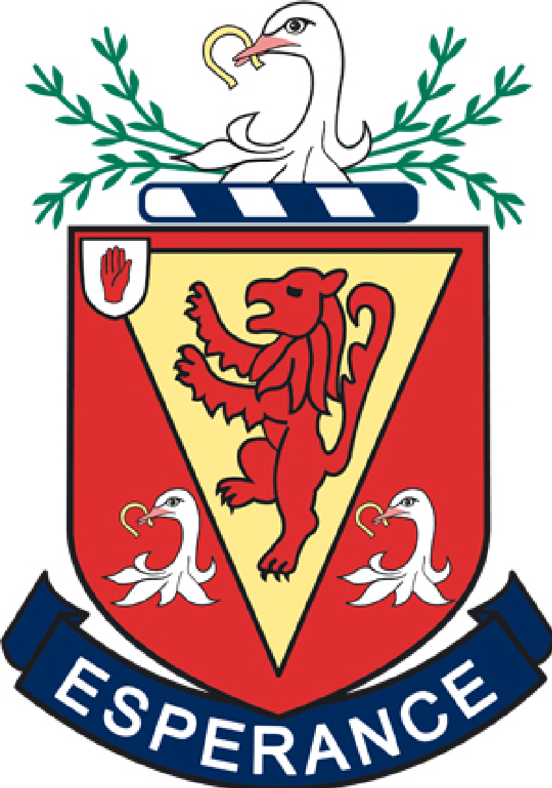

The Wallace High School
Key Stage 3 Curriculum

Updated September 2017

Year 8

Art & Design | Biology
Textiles  Observations, researching the work of textile artists, developing design ideas, textile practical techniques.  3D construction  Observations, researching the work of sculptors , developing design ideas, 3D construction techniques. | Cells  Reproduction in Plants and Animals  The Brain and Senses  Ecology
Chemistry | Computing
Getting Started  Chemical changes  Acids and Alkalis  Solutions and Separations  Atomic structure and Periodic Table | Keeping Safe on the Internet.  Programming using Scratch.  Using Lightbot App.  Creating Web Pages using html.
Drama | English
•What is Drama?  •Roles and Responsibilities  •Staging  •History of Theatre  •Theatres around us  •Improvisation  •Silent Movies  •Gestures  •Scriptwriting  •Characterization  •Musical Theatre  •Review Writing  •PR | •School and Special Times  •Developing Comprehension skills  •The Sea  •Novels  •Introduction to poetry  •SPG  •Personal, creative and descriptive writing  •Creating multi modal texts  •Introduction to Shakespeare- Macbeth
French | Geography
Meeting, Greeting and Getting to know you  In the classroom  Where people live  The Family  School Environment  Daily Routine  Sports and Hobbies  Pets  Physical attributes and personality descriptions | Geography Passports & What is Geography?  A Sense of Place (UK & NI)  Settlement  OS Map Skills  Careers - Famous Geographers  Weather and Climate  Ecosystems and People  Economic Activity - Farming

History | Home Economics
What is History?  Why study History?  Historical Skills  Who were the Normans?  The events of 1066  Contenders for the Throne  Williams Problems  The Normans in Ireland  Optional topic post May examinations | Let's Get Started - an introduction to Home Economics  What's on Your Plate? The Eatwell Guide  Family matters  Throughout the year pupils make a range of dishes to demonstrate their ability to prepare food in a safe, hygienic and creative way.  Pupils are given opportunities to develop a wide range of transferrable skills e.g. independent learning, working with others, ICT.  Four core assessment tasks are completed and contribute to formal examinations i.e. end of unit test and practical exam (Winter Session); coursework and practical exam (Summer Session).
Learning for Life and Work
Employability
In Year 8 students begin the process of career planning and the factors that can affect them including the global market. In particular:

• The skills and qualities that employers are looking for, their past, present and future career ideas
• Setting personal goals, beginning to plan for their future to include careers research
•The type of jobs in both the local and global Economy
• What is Enterprise and how enterprising are they?

Citizenship
In Year 8 students study the topics of identity and diversity including:

• Factors that influence identity
• The ways in which identity can be expressed
• How and why conflict may arise in the community
• How conflict may be managed and positive community relations promoted

Pupils conclude Year 8 by beginning to examine human rights instruments before studying the topics of equality and social justice in Year 9.

Personal Development
Year 8 students begin to explore:
• Health as the development of a whole person
• Influences on physical and emotional /mental personal health
• Strategies to manage, the effects of change on body, mind and behaviour
• Preventative strategies in relation to accidents in the home, school and on the road
• The qualities of relationships including friendship & the qualities of a loving respectful relationship
• Sense of self
• Influences on a young person
• Personal morals, values and beliefs
• Strategies to improve own learning

Mathematics | Music
In Year 8 pupils will study the following components of Mathematics:  • Number including; Use of 4 main operations with whole numbers, fractions (only + & -) and decimals, simple percentages, directed number, binary form and numerical patterns  • Algebra including; Equations up to unknowns on both sides and use of formulae.  • Shape, space and measure including; angles in shapes and around parallel lines, triangle and quadrilateral properties, area and volume of common shapes, coordinates and metric and imperial units.  • Handling Data including; Collecting, displaying and grouping data and mean, median and mode from a list. | Putting on a concert and the four chord song  What makes a good song?  Elements of Music and Active Listening  Polyrhythms and Minimalism
Physics | Physical Education
What is Science  Forces  Energy  Space | Movement Skills  Gymnastics  Basketball  Athletics  Softball
Religious Studies | Technology & Design
Module on Thinking skills, alongside Christian and opposing opinions:  1. Listening and analysis skills  2. Jesus in the Gospels and other writings  3. Miracles, particular focus on Jesus’ supernatural birth  4. Sermon on the mount  5. Jesus' death and resurrection | 1. Communication Task - Health and Safety modelling in groups.  2. Graphics - Basic drawing techniques. (Simple shapes, rendering, isometric)  3. Design - Design of Bug Project  4. Manufacture - workshop skills and safety to produce (a) picture frame  (b) soldered circuit and vacuum formed housing for bug project.  5. Theory Health and Safety, Materials and Electronics.  6. ICT - Keynote presentation/log of design and manufacture activities.

Year 9

Art & Design | Biology
Colour Theory  Introduction to colour theory.  Book Illustration  Manipulating Art Studio Tools  Print  Observations, researching the work of artists, developing design ideas, printing practical techniques.  Gallery visit assignment | Diet and Digestion  Breathing and Respiration  Plant Biology
Chemistry | Computing
Elements, Compounds and Mixtures  Reactions (part 1 and energy changes)  Patterns of reactivity and Displacement Reactions  Kinetic theory  Careers | Cyber bullying.  Creating a Quiz App in html.  Programming in Python
English | French
• Heroes  • Magic and Mystery  • Environment  • Introduction to literary analysis – essay writing  Introduction to Victorian Prose Criticism  • The Apprentice  • Persuasive writing  • Functional writing  • Class Novel  • SPG  • Analysing and creating multi modal texts  • Shakespeare’s Romeo and Juliet | Home and Local Environment  Transport  Food and Drink  Shopping for food and souvenirs  School Environment  Health and Healthy eating
Geography | German
A Sense of Place - Europe and the EU  Rivers (processes & landforms) and Flooding  Careers - the Perfect Geographer  Population and Migration  Glaciation (processes & landforms) and Avalanches  Rocks and Weathering | Meeting, Greeting and getting to know you  My Family  My school  My house and home  Food and drink  Hobbies and interests

History | Home Economics
The Reformation  Henry VIII  Mary Queen of Scots  The Spanish Armada  The Planatations in Ireland  The English Civil War  Oliver Cromwell in Ireland  The Restoration  The Williamite Wars in Ireland | Unit 1 Food and Nutrition  Unit 2 Taking Care of Your Food (Food Safety)  Unit 3 Growing Up (Babies and Young Children) and Growing Older  Pupils prepare a range of dishes in class when studying each Unit e.g. Chilli con carne to demonstrate their ability to prepare food in a safe, hygienic and creative way  Pupils have opportunities to develop a wide range of transferrable skills including research, independent learning, working with others, being creative  Four core assessment tasks are completed throughout the year which contribute to formal examinations i.e. Winter session - an end of unit test and a practical examination; Summer session - a practical examination and a coursework task.
Learning for Life and Work
Employability
Year 9 students develop their understanding of career planning and the impact of the global market. In particular, they cover:

• Career Management
• Working in the Local and Global Economy
• The skills for Enterprise and Entrepreneurship

Citizenship
Students address the following topics:
• How and why inequalities arise in society and how these can be seen
• How and why people may experience inequality and social exclusion
• The roles of intergovernmental, governmental and nongovernmental organisations which aim to promote equality and social justice

Personal Development
Year 9 students continue to develop and explore:
• Health and the whole person
• Strategies to manage, the effects of change on body, mind and behaviour
• Preventative strategies in relation to accidents in the home, school and on the road & Strategies to promote personal safety
• Effects on the body of legal and illegal substances values and beliefs
• Qualities of relationships including friendship & Qualities of a loving, respectful relationship
• Different ways to develop self esteem
• Skills and strategies to improve own learning
• Explore and express a sense of self
• Personal morals, values and beliefs

Mathematics | Music
In Year 9 pupils will study the following components of Mathematics:  • Number including; Multiplication and division of fractions, rounding including significant figures, change between decimals, fractions and percentages, standard form and indices and ratio.  • Algebra including; breaking brackets, substitution, equations involving fractions,  • Shape, space and measure including; further areas of triangles and quadrilaterals, area and circumference of a circle, Pythagoras’ Theorem, transformations, scale drawing and angles around polygons.  • Handling Data including; Mean, median and mode from a list, basic probability, scatter graphs and correlation, | Blues and Jazz  Elements of Music and Active Listening  Music notation  Latin American rhythms
Physics | Physical Education
Light  Sound | Gymnastics  Fitness  Tennis  Athletics  Softball
Religious Studies | Spanish
Module on Islam  1. Muhammad and the beginning of Islam  2. The five pillars of Islam  3. Islamic beliefs and practises.  Module on Early Church  1. Major stories of Acts  2. Writing materials of the Bible | Spain and the Spanish-speaking world  Number, ages and birthdays  Where people live  The family  Descriptions  School
Technology & Design
1. Communication Task - Mini Company (Animal Conservation/ Protection).
2. Graphics - Development of drawing techniques. (More complex shapes/products, rendering, isometric)
3. Design - Design of Mechanical Toy Project.
4. Manufacture - workshop skills and safety to produce (a) Mechanical Toy.
5. Theory Health and Safety, Materials and Mechanisms.
6. ICT - Keynote presentation/log of design and manufacture activities also to include information on purpose of Mini Company. 3 fold leaflet (Company based).

Year 10

Art & Design | Biology
Careers research assignment  Ceramics  Observations, researching the work of artists and designers, developing ideas and practical ceramic techniques.  Independent project work:  Observations, researching the work of other artists and designers, developing ideas through experimentation in variety of techniques which might include: paint, collage, mixed media, photography, print. | Blood and Circulation  Microbes and Disease  Genetics and Inheritance  Ecosystems
Chemistry | English
Reactions (part 2) Neutralisation  KS 3 ICT Accreditation  GCSE Atomic Structure  GCSE Bonding  GCSE Structures  GCSE Nanoparticles  Writing Formulae and equations | •Persuasive writing  •Irish short stories  •Writers’ craft/ method analysis  •Poetry on the theme of death – writing analytically and creatively  •Creative writing - Friendship  •Careers in English  •Feature writing - Journalism  •Shakespeare - close study  •War Poetry – structuring a formal poetry essay  • Developing unseen analysis - prose criticism  •Novel to film unit
French | Geography
A mon avis and asking people out  Préparer une visite  Savoir vivre  Découvrir le monde | A Sense of Place - the World  Plate Tectonics (earthquakes and volcanoes)  Development Indicators  Globalisation  Careers - jobs, skills and apps  Global issues - Fair Trade, Coffee and Aid  Fragile Ecosystems - tropical rainforests, deserts and coral reefs
German | History
My town  Transport  Weather and seasons  Making arrangements to go out  Supermarket and café  At the weekend  Physical and personality descriptions and relationships  Daily routine, household tasks and pocket money  Travelling around town  Shopping and Services  School  Body Parts and Illness | World War One  The Holocaust  The Suffragettes  The Jazz Age  The Rise of the Nazis  Nationalism in Ireland  Revolutions in the USA and France  The Partition of Ireland  The Beginning of the Troubles

Home Economics
Dietary Disorders
Sports' Nutrition
Wiser Buyer (consumer topic)
Throughout the year pupils make a range of dishes to demonstrate their ability to prepare food in a safe, hygienic and creative way.

Pupils are given opportunities to develop a wide range of transferrable skills e.g. independent learning, working with others, ICT.

Four core assessment tasks are completed and contribute to formal examinations i.e. end of unit test and practical exam (Winter Session); coursework and practical exam (Summer Session).

Learning for Life and Work
Employability
In Year 10 students focus their career plan in conjunction with the GCSE option choice process. In particular:
• A review of their skills and qualities
• Identifying job families including identification of learning styles
• Undertaking focused careers Research and using local market information
• Writing a Personal Career Plan with established goals to include the GCSE option choice process
• Writing a CV and Personal Statement
• Undertaking a Dragon's Den style entrepreneurship exercise

Citizenship
The final topic in Year 9 acts as a bridge into Year 10 when pupils will examine:
• The basic characteristics of democracy
• Ways to participate in school and society
• The necessity of rules and laws
Pupils will also return to the explicit study of human rights when studying:
• The importance of upholding human rights standards in society
• Why different rights must be limited
• Scenarios where rights may have been infringed
Pupils conclude their study of Local and Global Citizenship through investigating an issue from a range of viewpoints.

Personal Development
Year 10 students continue to develop and explore:
• Health and the whole person
• Effects of change on body, mind and behaviour
• Effects on the body of legal and illegal substances and the risks and consequences of their misuse
• Effects on the body of legal and illegal substances and the risks and consequences of their misuse
• Personal morals, values and beliefs
• Developing Self esteem
• Influences on a young person
• Strategies to improve own learning

Students also focus on:
• Relationship Scenarios & Dealing with conflict
• Qualities of relationships including friendship & Qualities of a loving, respectful relationship
• Implications of sexual Maturation
• Implications of early sexual activity

Mathematics | Music
In Year 10 pupils will study the following components of Mathematics:  • Number including; further use of negative numbers, percentages, trial and improvement and fractions with all four operations.  • Algebra including; algebraic products and factors, simultaneous equations by elimination, changing the subject of a formula, sequences, algebraic fractions, graph drawing and coordinate geometry.  • Shape, space and measure including; trigonometry and volume and density.  • Handling Data including; Cumulative Frequency, Stem and leaf diagrams, Box and Whisker diagrams. | ICT accreditation task; Creating a soundtrack  TV Themes  Music in Advertising  Film Music and Casino Royale
Physics | Physical Education
Electricity  Turning Forces  Magnetism | Badminton  Fitness  Basketball  Athletics  Softball
Religious Studies | Spanish
Module on Buddhism  1. Story of the Buddha and path to enlightenment  2. Beliefs about the life cycle and nirvana  3. Teachings of the Buddha; focusing on the Four Noble Truths and the Eightfold Path.  Christian Ethics (GCSE module start)  1. Abortion  2. Euthanasia | En casa  Mi pueblo  En mi tiempo libre  La comida
Technology & Design
1. Communication Task - KS3 ICT Accreditation based round production of Key Fob.
2. Graphics - Perspective Drawing. (Complex shapes/products in 1 point and 2 point perspective with some development of 3point), rendering.
3. Design - Design of Key Fob and Light Alarm projects
4. Manufacture - workshop and CAD/CAM skills and safety to produce (a) Key Fob (b) soldered circuit and housing for Light Alarm.
5. Theory Health and Safety, Materials, CAD/CAM and Electronics.
6. ICT - Keynote presentation for Key Fob, design and manufacture skills for use of Laser Cutter (CAD/CAM).

