My UK German Connection experience – Anneliese Whiteside – 12Z
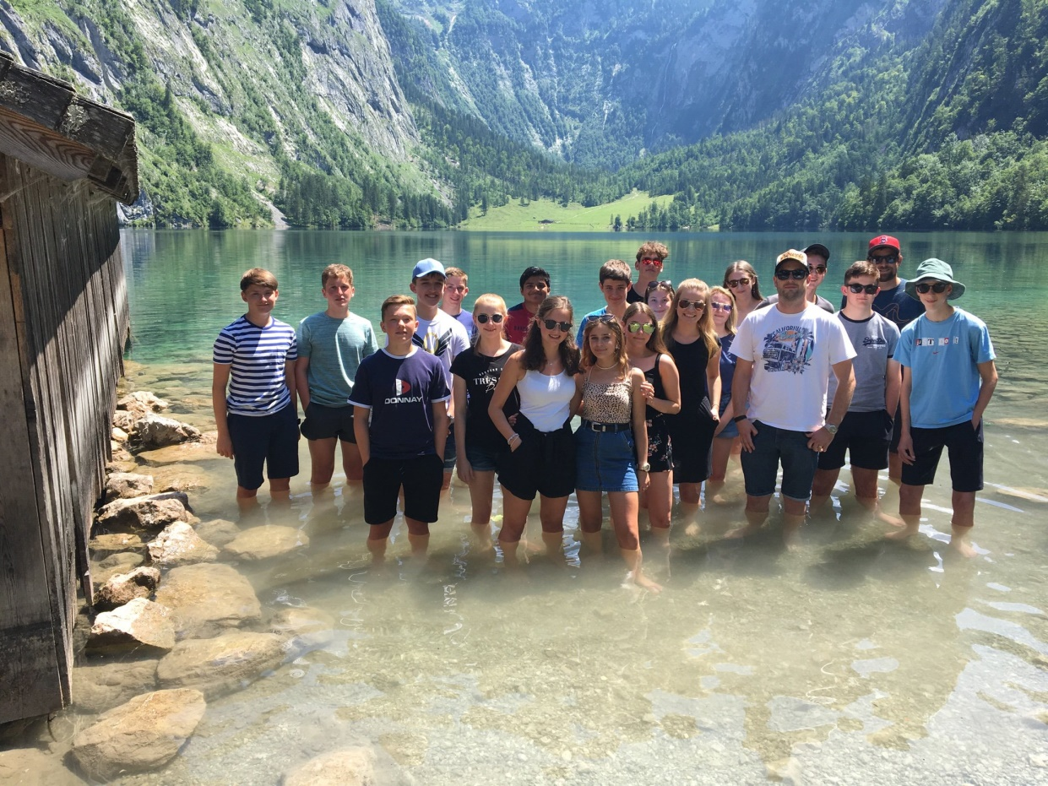
It was 4.00am on Saturday 13th July and I was travelling to Belfast City Airport to catch a flight to London Heathrow and onwards to Munich. I didn’t have a clue what was ahead of me and I was wondering, “Why on earth did I put my name forward for this?” This was the UK German Connection Course and I was on my way to spend 2 weeks with a German family in Bavaria. When I arrived at the airport, I met the other 2 pupils from Northern Ireland who were also taking part. We flew to London Heathrow and met up with 11 other pupils from all over England. On our arrival at Munich Airport, we were surprised by our “Gastfamilien” as they were supposed to meet us at their school. I’m not going to lie, it was a little awkward at first, but once Lisa, my “Gastschwester”, and I got talking on the bus I knew it would be fine! That evening, my host family and I went for pizza and then to watch a fantastic fireworks display over the River Danube called “Donau in Flammen”.

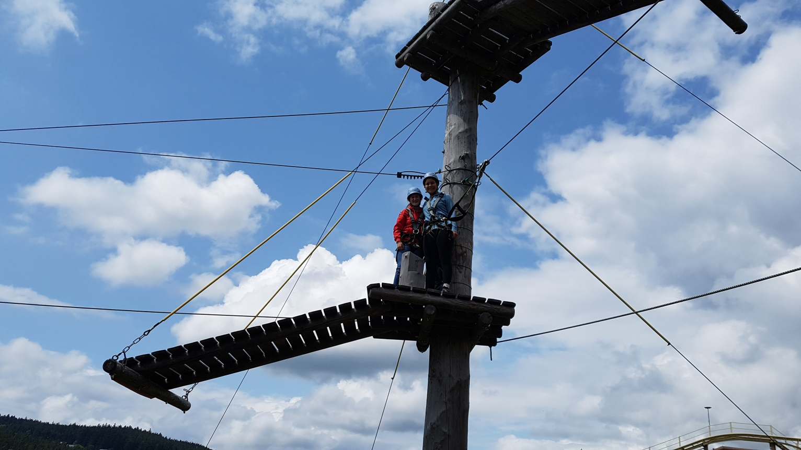
On the Monday morning, I travelled on the bus with Lisa to her school, the Evangelische Realschule in Ortenburg, where I met up with the other participants again. I attended the school for the next 2 weeks and during this time we went on lots of trips and took part in many different lessons such as German language, PE, where we learnt a new game called “Völkerball”, and cookery lessons, where we made some traditional Bavarian dishes including “Leberkäse”, “Kartoffelsalat” and pretzels – they were delicious! We even had a lesson in which we learnt a traditional Bavarian dance. This we performed flawlessly on the last evening. One unforgettable experience was our trip to the Bavarian Alps. On this day it was over 30°c so when we stood in the crystal clear, blue waters of the Königssee, it was really refreshing. My host family also took me to do lots of fun things such as zip-lining down a mountain, going for ice cream, shopping in Passau and going to a traditional beer festival.

I definitely stepped out of my comfort zone by going on this trip and I’ll admit I was a little homesick at the beginning, but my host family were very kind, welcoming and they kept me busy. It was an amazing experience and I was lucky to have the opportunity to take part in this programme. I met some lovely people, with whom I am still in contact. I learnt so much and, most of all, my German listening and speaking skills and my confidence have definitely improved.

