My UK German Connection experience – Holly Mackin – 14 3

This summer I pushed myself out of my comfort zone when I took part in a two week German language exchange to Berlin. With all expenses paid, I felt incredibly lucky that my application to UK German Connection was successful and that I could take part in this unique experience.

After much paperwork, I finally met up with my group, made up of 12 young language enthusiasts, in Heathrow Airport. We all clicked immediately as a group and were able to share our love of languages together. Many of us also studied French and there was a native French speaker amongst us, giving us more opportunities to speak French as well!

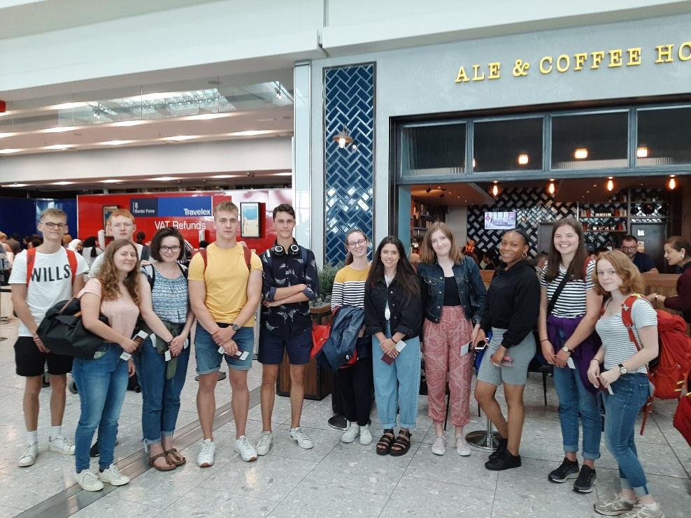

When we arrived in Berlin we went straight to our host families which was initially daunting as we were thrown into an only-German speaking environment, however this was possibly the best thing for us as it ensured we built up fluency and, by the second week, I started thinking automatically in German!

The two week stay consisted of classes in school and activities with the group from the UK, joint thematic workshops with the German pupils and also opportunities to teach young German primary school pupils. In the evenings and at the weekend our host families helped us experience authentic German culture and explore the city of Berlin, but not just from a tourist stance.

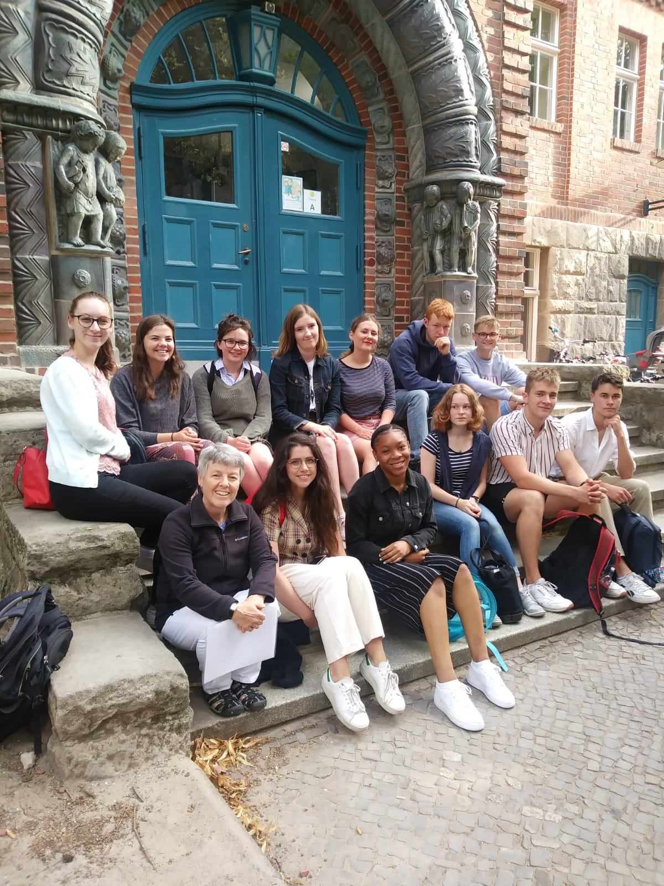

The first weekend I hit all the main tourist spots in Berlin and visited many museums due to my keen interest in Berlin history. My host father lived in former East-Berlin and we would have endless conversations about his life in such a closed-off society as the DDR was.

My host partner introduced me to all of his friends and this helped me experience Berlin in a raw way as I gained an insight into teenage culture in a major European city. I particularly enjoyed the area of Kreuzberg, an urban and hip area with many parks, graffiti walls and skate parks.
My host family ensured my diet was truly German and I ate Schnitzel, Bouletten, Bratwurst and Sauerkraut on a daily basis! I particularly enjoyed the cooking course I took part in as I tried to navigate myself around the kitchen following quite specific German instructions.

It was truly an invaluable experience to be able to live the life of a German student as I went to school and attended classes taught solely in German. We even had the opportunity to teach younger German pupils English. While it was completely different to school life in Northern Ireland, I still enjoyed the degree of freedom we were given as we were able to wear our own clothes and choose our own lunch times.

As it was the middle of August, the temperatures were quite high in Berlin and my German family took me to one of the major lakes in Berlin called ‘Schlachtensee’. The atmosphere was tranquil as Berliners would come to get a break from the bustling city and to cool down in the water.

A poignant day was when I saw German Chancellor Angela Merkel at a ‘Hallo Politik’ event at the German Reichstag. Despite the sea of people and the cramming, it was still a once in a lifetime opportunity to see her. I additionally feel I became a pro at navigating myself around the large city, having used public transport numerous times each day. Another positive aspect is that it is free for all students!

Contrasting to the busy days I spent exploring Berlin, my family ensured I was completely immersed in German culture as we spent nights gathered around the TV watching old iconic German films such as ‘die Feuerzangebowle’. My host family loved to learn about Northern Ireland and had a keen interest in our history which allowed for engrossing conversations to flow at dinner times.

Berlin is a city like no other and a city for everyone. From music festivals, food markets and shopping, I feel I got to experience most of what the city had to offer in just two weeks. I would like to thank UK-German Connection for this opportunity. I pushed myself to my limit and tested my linguistic skills. I got to learn the German language in the most effective way and build up a fluency that you cannot build up in your home country. It is difficult to completely surround yourself in a foreign environment, even harder when you are not using your mother tongue.
I gained personal qualities and also skills which will serve me for the rest of my life.
Es war eine einmalige Chance im Leben!

