My UK German Connection experience – Olivia Palmer – 14 4

Participating in the UK German Connection Pupil Course this summer was a truly unique and unforgettable experience. As a result of my time in Germany my confidence in speaking and conversing in German has increased immensely and I have also developed a lot as a person within such a short space of time.
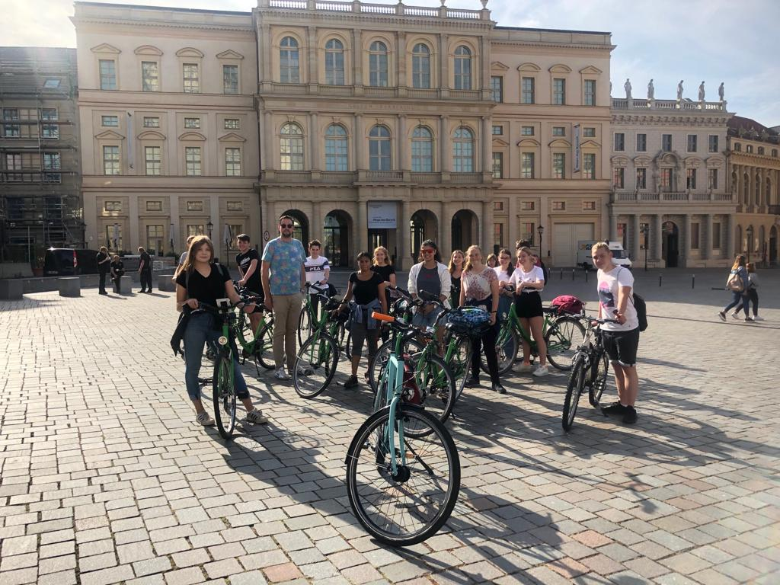

I stayed in a little village called Brieselang, about 15 minutes from the centre of Berlin. Despite the nerves I felt at the beginning of my two week stay, I settled in very quickly with my Gastfamilie (host family) and I am so grateful to them for all the great memories.
A highlight of my time with them was a bike tour of Potsdam and our visit to the Wannsee Konferenzhaus, during which I learnt a lot about the fascinating history of Germany and what everyday life consisted of for Germans during the 2nd World War. Living with a host family for 2 weeks enabled me to fully immerse myself in the German culture and lifestyle, an aspect of the course which I thoroughly enjoyed and which greatly improved my language ability.

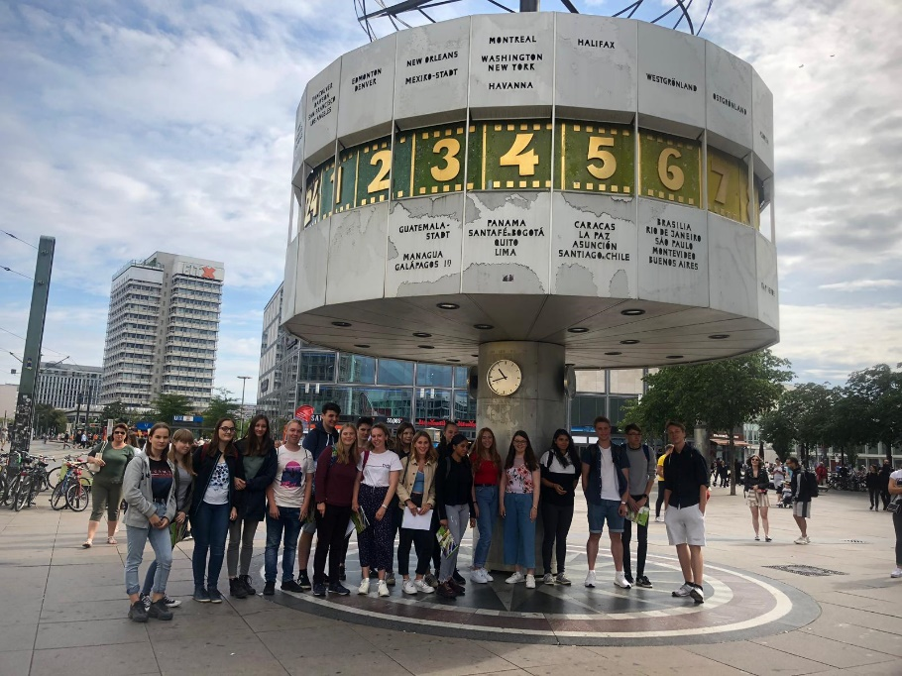

During my time in Germany I also made great friends with all of the other course participants from the UK and we enjoyed lots of exciting excursions together as a group, my favourite being a sight-seeing tour around Berlin during which we visited various cultural and historical landmarks of Germany including the Reichstag building, the Brandenburg Gate and the famous East Side Gallery of the Berlin Wall. I also attended school with my Gastschwester (host partner) and I found this really interesting as I was able to both improve my German through challenging grammar lessons as well as experience daily life as a German pupil.

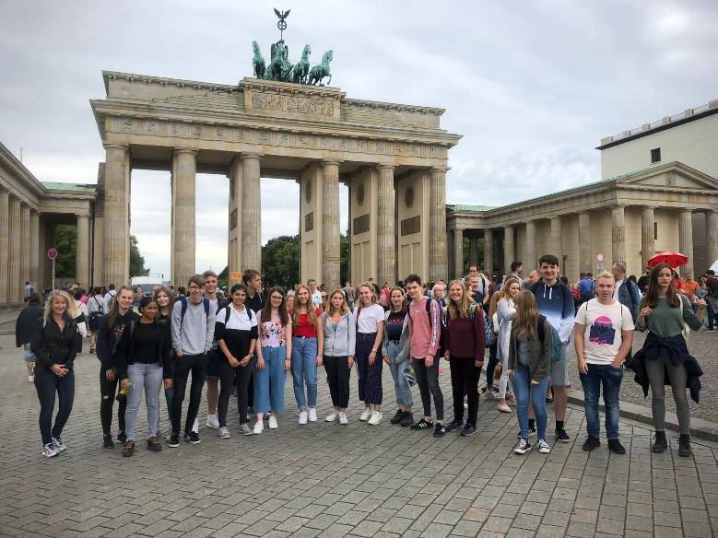

I would highly recommend this course to anyone interested in German who wants to both improve their language ability and learn more about the German culture. The friends and memories I made during the 2 weeks were amazing and I really hope to return to Germany soon to further improve my language skills.

