My UK German Connection experience – Rachel McCullagh – 12X

I had one of the most amazing experiences of my life this Summer. After applying for a UK German Pupil Course and not being offered a place, I was given the opportunity to take part in a week long Cultural Immersion Course in Garmisch-Partenkirchen. Despite being an independent person, it was still very nerve wracking to be living with 14 other people I did not know in a country I had never been to before. Out of the 15 people on the course, 4 were from Northern Ireland, so a couple of weeks before the course we decided to meet up to get to know each other.

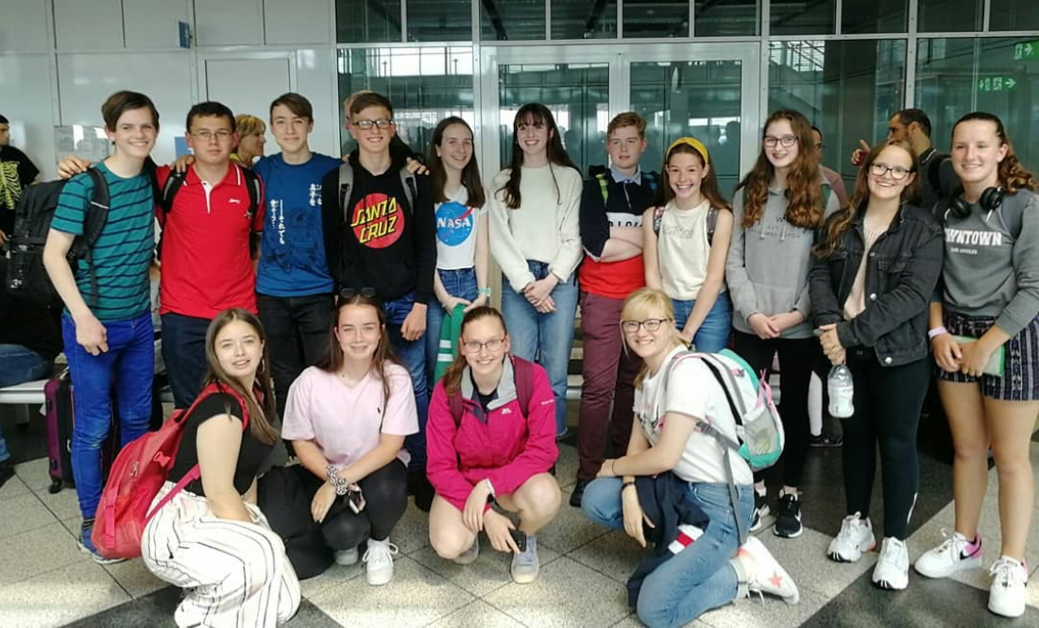
It was very early on the 20th of July when my exciting journey to Germany started. My first stop was Belfast City Airport where the Northern Ireland contingency caught their first flight to London Heathrow. We then met up with the rest of the course participants. At this point we were all still quite nervous. Then it was off to Munich on our next British Airways flight, this time with the whole gang.
As soon as we stepped of the plane it was clear we were in a different climate, as it was extremely humid, in fact it was around 36 degrees. We then had a 4 hour coach journey to our modern hostel “Moun10”.

During our time in Germany we had many fun trips and excursions, for example we went to the local ski jump and climbed all the way to the top, hiked up the Alpspitze, visited the Partnachklamm, which had the most amazingly blue water and went swimming in lake Eibsee.
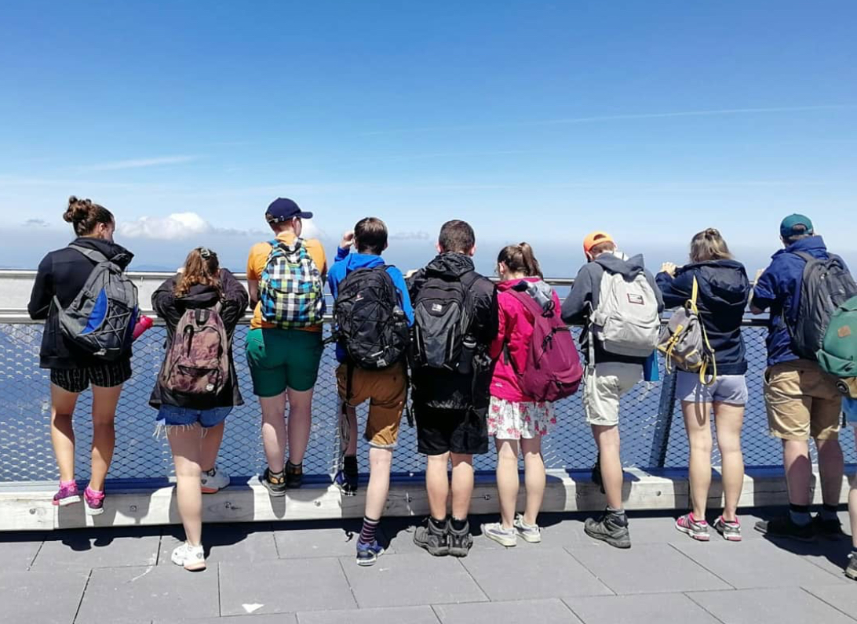
However, my highlight would have to be going up the Zugspitze and being at the highest point in all of Germany.

Even though we did have a lot of excursions, we still managed to fit in language lessons and workshops. My favourite of the language lessons was on German idioms like “auf Wolke sieben” and “im Eimer sein”. For our workshops we worked with the local grammar school to talk about topics such as mental health and nature. This was probably the hardest part of the course, as we had to try and have conversations with each other in German.

I had so much fun on this course and I would recommend it to anyone who wants to learn about German life and history. As a group we had a laugh and we had some great inside jokes like “Helgaud goes to a French school” and “Klaus der Bayerisches Bär der Lederhosen trägt”.
It was an experience of a lifetime.

