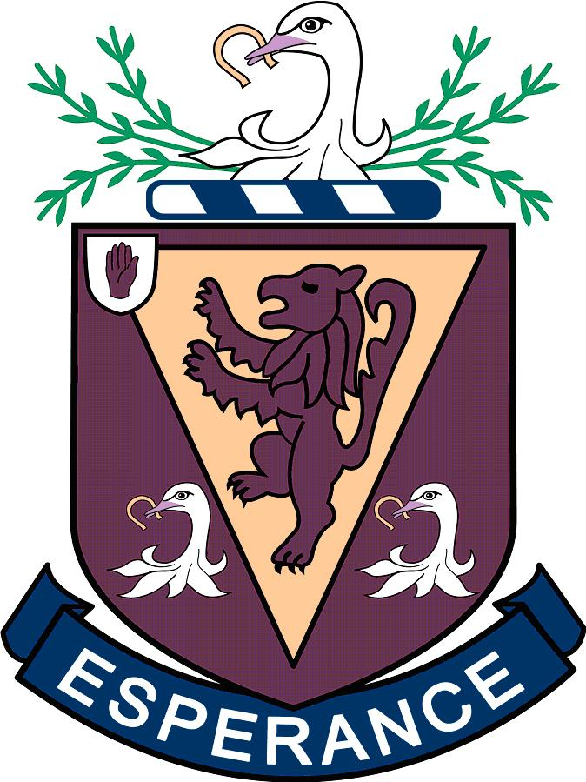

ANTI BULLYING POLICY

The core aims of Wallace High School are commitment, opportunity, respect and excellence for all pupils within the school community. Therefore, Wallace High School aims to create an atmosphere in which all pupils have a right to learn free from intimidation or fear and have a clear understanding that bullying thrives on being ignored¹. The Wallace community repudiates bullying behaviour of any kind, to any member of the school community, by any member of the school community.
¹ “Bullying thrives on secrecy, the reluctance of the target to talk about it and the reluctance of responsible adults to acknowledge its existence.”
Pastoral Care in Schools – Promoting Positive Behaviour (June 2001)
Context
This policy is informed and guided by current legislation and DE Guidance listed:

Legislative context
- Health and Safety at Work NI Order 1978 The Children (Northern Ireland) Order 1995
- The Human Rights Act 1998
- The Education (Northern Ireland) Order 1998 Article 3 – see DE 1998/25
- Welfare and Protection of Pupils Education and Libraries (Northern Ireland) Order 2003
- The Education (2006 Order) (Commencement No.2) Order (Northern Ireland) 2007
- The Education (School Development Plans) Regulations (Northern Ireland) 2010
- Addressing Bullying in Schools Act (Northern Ireland) 2016

Policy and Guidance context
- Pastoral Care in Schools: Promoting Positive Behaviour DE, 2001
- Safeguarding and Child Protection in Schools. A Guide for Schools DE 2017
- Addressing Bullying in Schools Act (Northern Ireland) 2016 Statutory Guidance for Schools and Boards of Governors 2019

Introduction
Wallace High School is completely opposed to any and all forms of bullying behaviour and operates a zero tolerance towards it. Respect for others is one of the core values which we expect all of the members of our school community to uphold and we view bullying as being contrary to this central belief. All members of our school community have a right to be free from being bullied and a responsibility to assist in whatever way they can to ensure that others are similarly protected. If bullying does occur, we are committed to dealing with it promptly and effectively.
The Board of Governors at Wallace High School undertakes to ensure measures to prevent bullying in school and the recording of incidents and alleged incidents of bullying involving a pupil at the school. Positive behaviour is encouraged in school through our CORE values, Commitment, Opportunity, Respect and Excellence, and the implementation of the school’s Positive Behaviour Management Policy, which addresses measures to prevent bullying.

Consultation and participation
This policy has been developed in consultation with registered pupils, parents, carers, staff and Governors.
Consultation has taken place through the school council and Executive Council meetings.
Online consultation for parents, teachers and Governors.
This policy will be reviewed at least every 3 years in consultation with pupils, parents, teachers and governors.

Definition – What is bullying?

The Addressing Bullying in Schools Act (Northern Ireland) 2016 defines bullying as, but not limited to, the repeated use of –
- any verbal, written or electronic communication,
- any other act, or
- any combination of those, by a pupil or a group of pupils against another pupil or group of pupils, with the intention of causing physical or emotional harm to that pupil or group of pupils. This may also include the act of omission.

The Northern Ireland Anti-Bullying Forum define bullying as – usually repeated behaviour that intentionally hurts, harms or adversely affects the rights and needs of another and others.
It should be noted that any behaviours regarded as socially unacceptable will be dealt with in line with our Positive Behaviour Policy.
Based on DE guidance provided, bullying behaviours will be intentional, targeted, repeated* and cause physical or emotional harm. The school considers harm to be:
- physical harm – intentionally causing injuries such as bruises, cuts, broken bones, burns
- emotional harm – intentionally causing distress, anxiety, humiliation or impacting
*In some instances, a one-off incident may be considered bullying behaviour. When determining if this is the case the school will consider the following:
- the severity and significance of the incident,
- evidence of pre-meditation,
- impact of the incident on individuals and the wider school community,
- previous relationships between those involved,
- and any previous incidents involving those individuals.

Incidents associated with bullying behaviour
Bullying behaviours can take a range of forms as noted below.**
Physical:
- includes jostling, physical intimidation, punching/kicking, any other physical contact which may include use of weapons.
- indirect contact e.g. spitting, throwing objects at someone, unacceptable gestures, taking or causing damage to personal belongings, defacing personal property.
- taking images of another pupil without their permission and/or sharing these with others.
Verbal (& written):
- includes name calling, insults, jokes, threats, spreading rumours;
- taunting; teasing; name-calling; mocking another due to physical characteristics, race, personal beliefs, sexual orientation, achievements or (perceived) personality traits, using abusive language;
- issuing threats.
- spreading rumours.
Indirect:
- includes isolation, refusal to work with/talk to/play with/ help others, interfering with personal property and includes cyber-bullying: misuse of mobile phones and internet programmes to humiliate, threaten and/or isolate another
- omission or excluding someone from a social group.
- blackmail, forcing someone to do something against his/her will.

Electronic:
- through the use of technology such as mobile phones and internet
- by text, by email, through use of chatrooms, via social media sites or by other web-based facilities. This may also include Impersonating someone online to cause upset/hurt.
(**list is not exhaustive)

Recording of bullying type incidents
At Wallace High School records of bullying behaviours will be recorded and stored electronically, with only staff directly responsible for the records through their role or responsibilities in school having access to these records. As well as recording the type of bullying behaviours and names of those exhibiting or experiencing bullying type behaviours we will also record the motivations for the behaviours, which may include: age, appearance, breakdown in peer relationships, cultural, religion, political affiliation, community background, gender identity, sexual orientation, pregnancy, martial status, young carer status, looked after status (LAC), disability, ability, race or other.**

Preventative Measures
The Wallace High School seeks to raise the awareness of and prevent bullying type behaviours by a registered pupil during the school day, while travelling to and from school during the term, while under the supervision of a member of staff of the school or while the pupil is receiving educational provision on behalf of the school. Preventative measures cover a range of class and whole-school activities, such as:

- consistent implementation of our Positive Behaviour Policy
- fostering in our pupils self-esteem, self-respect and respect for others through the delivery of the pastoral development programme, assemblies and visits by external speakers
- demonstrate by example the high standards of personal and social behaviour we expect from our pupils.
- address bullying through the school council discussions and listening to views on how to best deal with these behaviours
- introduction and promotion of the Anti-bullying charter
- monitoring and reviewing supervision arrangements in areas such as the Link, canteen, playgrounds, corridors and toilets.
- be alert to signs of distress and other indications of bullying both inside and outside the classroom.
- Active whole school participation in NIABF’s Anti-bullying Week activities
- Provision of a supervised quiet environment at break and lunch time accessible to pupils
- listen to children who have experienced bullying type behaviours and take what they say seriously as well as acting to support and protect them.
- Encourage all staff to report suspected cases of bullying to the Head of Year, Assistant Head of Year or Vice Principal (Pastoral).
- Train staff in the recognition and reporting of bullying type behaviours through staff development and INSET programmes
- Ensuring pupils and parents have an understanding of how to report incidents of bullying type behaviours
- Allocating prefects to act as mentors for junior school classes, ensuring they know how and when to report any concerns they may have or are passed to them by a pupil.
- Working with external bodies such as Translink to unacceptable behaviour is not tolerated on journeys to and from school.

The Responsibilities of staff

Our staff will:
- follow up any complaint by a parent about bullying and report back fully on the action that has been taken.
- deal with observed cases of bullying promptly and effectively in accordance with agreed procedures

The Responsibilities of Pupils:

We expect our pupils:

- to understand that all pupils at Wallace have a right to be protected and to behave in a caring manner towards other members of the school community.
- to refrain from becoming involved in any kind of bullying type behaviours.
- to report to a member of staff any witnessed or suspected instances of bullying type behaviours.
- to refrain from ‘doing nothing’ recognising that to do so may mean that pupils experiencing bullying type behaviours continue to suffer.
- to help foster inclusive friendships so that other pupils do not feel isolated or excluded.

The Responsibilities of Parents

We ask our parents to support their children and the school by:

- watching for signs of distress or unusual behaviour in their children, which might be evidence of bullying.
- advising their children to report any bullying type behaviours to any member of staff, who will then inform the relevant Head of Year.
- advising their children not to retaliate violently to any form of bullying type behaviours.
- being sympathetic and supportive towards their children and reassuring them that appropriate action will be taken.
- informing the school of any suspected bullying type behaviours, even if their children are not involved.
- co-operating with the school if their child is accused of bullying type behaviours, try to ascertain the truth, and point out the implications of bullying type behaviours both for the children who are bullied and for the bullies themselves.
- carefully monitoring their children’s use of the internet and mobile phone.

Procedures for dealing with reported incidents

- Any reports of bullying type behaviours, in the first instance, will be reported to the Head of Year, or, in their absence, the Assistant Head of Year. The VP (Pastoral) will also be informed and an appropriate strategy will be agreed.
- The report of bullying will be investigated promptly and recorded electronically. Written statements may be taken. Following investigations the school will decide whether the reported incident is bullying or anti-social behaviour.
- A record will be kept of all significant aspects of the incident and the incident will be logged in the school’s bullying register.
- Parents/guardians of both the pupil experiencing bullying behaviour and the pupil displaying bullying behaviours will be contacted.
- The pupil bullied will be given immediate practical help and support to ensure they are able to experience all aspects of normal school life without fear of further bullying or recrimination.
- Continued support will be given, where necessary, and a member of the Form Staff will follow up at a later date to ensure the matter has not re-occurred.
- It will be made very clear to the pupil displaying bullying type behaviours that their behaviour is totally unacceptable. Advice will be given to help the pupil to change their behaviour and they will be carefully monitored until staff are satisfied that the behaviour has stopped. If appropriate assistance from outside agencies may be sought.
- Appropriate disciplinary action will be taken in line with the school’s Behaviour Management Policy*. The range of sanctions includes withdrawal of privileges, Friday detention, Saturday detention, suspension or expulsion for severe or persistent unacceptable information.

Links with other school policies

The school also has a Child Protection Policy*. It is important to distinguish between bullying and child abuse carried out by another child. If the latter is suspected then the school’s child protection procedures will be followed for both the victim and the alleged abuser.

* Copies of the school’s Pastoral Care, Child Protection and Behaviour Management Policies can be found on the school website www.wallacehigh.net, the school prospectus, or can be obtained on request from the school office.

Useful Contacts

Childline (08001111) – www.childline.org.uk. provides confidential advice to young people via telephone and on-line. A service of the NSPCC.

BullyingUK - www.bullying.co.uk. Offers advice to pupils, parents & schools on how to deal with bullying. Has many links to other useful UK-based websites.

Kidscape – www.kidscape.org.uk. Offers advice to pupils, parents & schools on how to deal with bullying. Has its own page on cyber bullying.

Parents Advice Centre (028 9023 8800) – www.pachelp.org. Provides help and support to parents facing any family difficulty including bullying.

Stop Text Bully – www.stoptextbully.com. Designed to offer advice to pupils, parents & schools on dealing with text bullying.

Chat Danger – www.chatdanger.com. A website designed to educate young people about the potential dangers of mobile phones, chat rooms, messenger websites & email.

Centre for Exploitation and Online Protection – www.ceop.gov.uk. Part of the UK police which is responsible for protection young people from on-line abuse. Find the latest information on the sites young people like to visit, mobiles and new technology. Find out what’s good, what’s not and what you can do about it.

NSPCC – www.nspcc.org.uk. Has some general advice on how to deal with bullying.

UrZone – www.urzone.com. A PSNI website which offers advice to young people on issues of importance.

Northern Ireland Anti-bullying Forum Website – www.niabf.org.uk. Hosted by Save the Children & funded by Dept. of Education. Offers advice to pupils, parents & schools on how to deal with bullying.

Policy review

It is the responsibility of the Vice Principal (Pastoral) to consider the effectiveness and application of this policy annually. This will be done in consultation with the Principal and the Heads of Year. To assist with this review the Vice Principal (Pastoral) may seek the views of a number of pupils (via the School Council), parents & staff (and will certainly be done no less regularly than every 3 years). Any revisions will be discussed with the Leadership Team before being presented to the Board of Governors for approval.

The views of pupils, parents & staff are welcome at any time & should be directed to the Vice Principal (Pastoral).

