
A warm Wallace welcome to Year 8!
Induction Activities

In the table below you will see an overview of all the activities we have organised for you as the first stage of your induction. Further details of each activity can be found at www.wallacehigh.org
Try to do as many as you can this afternoon!
If you don't have all the materials you need, perhaps you will return to this page and try some more over the next few days?

Don't forget to take pictures or videos of everything you achieve this afternoon!
Good luck!
Activity | What do I need to do?
What's Your Name?   | Watch Mrs Black's video https://youtu.be/QCkptbVOxYs  Mrs Black explains how to use the letters of your first name to talk about your personality, your interests or your appearance. Do your family members agree with your description?
Mathematical Snake | As you solve each question, the answer will feed into the next problem.....can you reach the end with the correct answer?  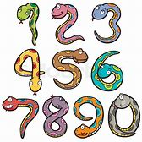
Posh Beans on Toast Challenge  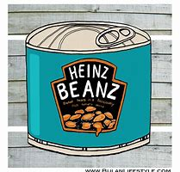 | Who can create the fanciest beans on toast using plain bread, a tin of baked beans and one other ingredient?  Send your photos to abittle@wallacehigh.net and we will announce the winning dish on our social media accounts!
Our Famous    Geography Quiz | You won't feel part of Wallace until you have a go at Miss McKee's infamous weekly quiz! This week's password is 'monkey'.
Getting Creative with Scratch   | How are your computing skills? Want to get ahead for your first term at Wallace?  Complete this simple Scratch tutorial and then animate the letters 'WHS' for Wallace High School!
Engineering Challenge:  Design and Build  a Helicopter! | 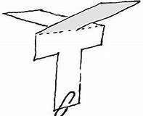  This paper helicopter task from Dyson only requires a piece of paper, some scissors and a paper clip!  Can you make your helicopter fly?
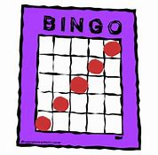  Lockdown Bingo | There are 12 challenges on the Modern Foreign Languages Lockdown Bingo grid.  Who can complete two or three of these? Or more?
Chemistry in Your Cupboard:  Making Icecream | https://youtu.be/-JcNMN0uvvE  Watch this short video and then have a go at making your own chocolate icecream!  All you need is chocolate milk, salt, some ice cubes, two Ziplock plastic bags.... and patience!  
Was 'Big School' always like this?   | Imagine you are a journalist and your job is to interview a parent, aunt, uncle, grandparent about their experience of 'Big School.'  Can you Zoom them to find out?  Maybe they were pupils at Wallace too!  Perhaps they were taught by some of your teachers?
Do you know how to  make a hand?   | Not a real hand of course! This activity shows you how to make a 'hand' out of drinking straws, paper or thin cardboard (like an old cereal box), string and some sticky tape!  Your articulated hand will amaze your family and confuse your pets! Why not decorate it too?

Finger print characters  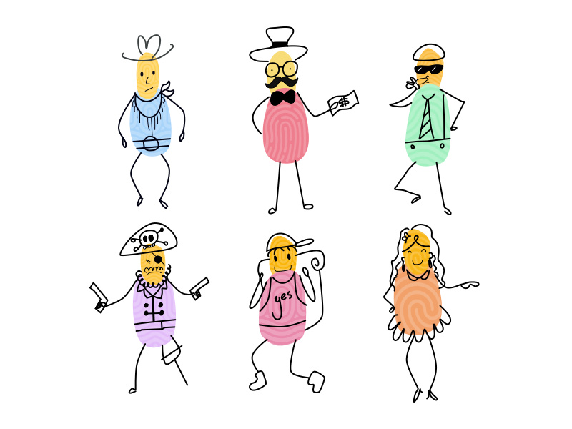 | https://www.tate.org.uk/kids/make/paint-draw/draw-fairy-tale  If you have any paper and paints or ink pads at home, then have a go at finger printing and then recreate some of your favourite characters from a film or a book!  What about adding some features to your thumb print characters and see if your family can guess who they are? Will they be able to recognise themselves or your friends?
Are you ready to take the  Egg Drop Challenge?   | Can you build a contraption to allow you to drop an egg without it breaking? Here are five ideas for you to try – or perhaps you could create your own?  https://youtu.be/nsnyl8llfH4  Mrs Crozier suggests you throw the egg (in its contraption) up in the air as hard as you can and see what happens when it lands.  Do NOT try this without an adult beside you!  Stay safe!!
  Win points for your House! | Complete the word search and email one of your Heads of House to win points for your House before you even arrive at Wallace!  afrey@wallacehigh.net  ddsimpson@wallacehigh.net

Don't forget to keep a close eye on our website www.wallacehigh.org
and encourage an adult at home

to follow us on Facebook and Twitter!

