The Wallace High School
Application Form
Post: Permanent Job Share Teacher of Spanish and French to A Level
Post Begins: 1 September 2024
Closing Date: Monday, 13 May 2024 at 12 midday
The Wallace High School

The Wallace High School is a co-educational voluntary grammar school situated in a pleasant residential area of Lisburn. It was founded in 1880 by a bequest from the estate of Sir Richard Wallace, local landowner and MP.

The School enjoys an excellent academic record both locally and nationally. The strong pastoral system ensures that individual pupils benefit from the support and guidance of their class tutor who monitors academic progress and general welfare. Through its curricular programme, wide range of extra-curricular activities and the expertise of well trained, specialist teaching staff, the School provides a balanced educational experience, encouraging pupils to discover and develop their particular talents, and preparing them for the opportunities and responsibilities of adult life referred to as ‘The Wallace Way’.

A strong emphasis is placed on extra-curricular activities, and a wide range of clubs and societies meet regularly. Pupil involvement is encouraged in music, drama and debating, while success is enjoyed by School teams playing rugby, hockey, tennis, athletics, badminton, netball and cricket. Pupils also benefit from the many opportunities afforded to them through School trips and visits, and through involvement in community service.

The School has recently invested in major enhancements such as new extensions and sports facilities, but the commitment at Wallace High School still remains to maintain high standards and maximise the potential of each individual pupil. The School has a strong reputation for innovation in the use of digital technology in learning.

Instructions to Applicants

Please read this before you complete the application form.

- Please do not attach additional sheets to this form. Covering emails/letters and CVs will not be considered by the panel.

- Please complete the form in Calibri font 12.

- Application forms should be emailed in Word format to recruit@wallacehigh.net. An acknowledgement will be sent by return of email.

- If shortlisted, you will be asked to sign the printed application form at interview, and present a form of photographic identification.

- Applications received after the closing date/time will not be accepted.

- It is up to the candidate to demonstrate on the application form how they meet each criterion

SECTION 1: PERSONAL INFORMATION
Office use only:
Ref: 2024/SpanishFrench/……….
Office use only:
Ref: 2023/Physics/……….

Title
First name |  | Middle name(s)
Surname |  | Date of Birth
Mobile number
Email address
Address
National Insurance No

SECTION 2: DETAILS OF PRESENT EMPLOYMENT

Name and address of present employer
Post held
Current salary |  |  |  | Teaching Scale/Responsibility Points
Main Duties
Period of notice required

SECTION 3: PREVIOUS EMPLOYMENT

Please provide the details of previous employment, starting with the most recent.

Name and address of employer | Job Title | From | To | Reason for leaving

Please explain any gaps in your employment history:

SECTION 4: EDUCATION

Please list below your A Level or equivalent, degree and postgraduate qualifications, grades or levels and the dates awarded.

Name of School/College/University | Qualification | Grade/Level  (if appropriate) | Date Awarded

SECTION 5: MEETING THE CRITERIA

Please indicate below how you meet the following criteria which are either essential or desirable (if not met please leave blank).

Essential Criteria
Applicants must (as of 1 September 2024)
Have a good honours degree (2:1 minimum) in French and Spanish, or French with Spanish or Spanish with French.
Be a qualified teacher recognised by the Department of Education (NI) and be registered with the General Teaching Council for Northern Ireland.
- GTCNI Number |  | - DE Teacher Reference
Be able to demonstrate the effective use of ICT in learning and teaching.
Show ability and be willing to contribute significantly to an extra-curricular activity offered in school (see list)
Desirable Criteria
Preference may be given to candidates who: (as of 1 September 2024)
* experience is only considered post teaching qualification (PGCE or equivalent), i.e. does not include teaching practice.
Have experience* of teaching French and Spanish to GCSE Level. Please provide specific dates of the teaching experience, the class size, if you shared the class or not.
Have experience* of teaching French and/or Spanish to AS and A2 level. Please provide specific dates of the teaching experience and the class size.
Show involvement in an extra-curricular activity offered in school.
Possess an appropriate qualification in an extra-curricular area.
SECTION 6: REFEREES

Please provide two referees. One referee should be your current Principal. If you are currently not working in a school, please include the Principal of the last school in which you worked.

Please ensure that you have notified your referee that you have listed their name. Depending on the post advertised, references may be called at any stage during the recruitment process.

Referee 1 |  | Referee 2
Name |  | Name
Job Title |  | Job Title
Organisation and address |  | Organisation and address
Email address |  | Email address
Telephone number |  | Telephone number

SECTION 7: DECLARATION

Shortlisted applicants will be asked to sign the application form at the interview stage.

I certify that the information supplied by me in this application is correct to the best of my knowledge.

I understand that prior to an appointment being confirmed, a criminal records check will be made on me for the purposes of fulfilling the requirements of the DENI Circulars 2006/06 “Child Protection: Recruitment of People to work with Children and Young People in Educational Settings” and 2008/03 “Child Protection: Pre-Employment checking of persons to work in schools – new arrangements”. I give my permission for this to be done.

I certify that I am not disqualified from working with children or subject to sanctions imposed by a regulatory body which would restrict me from applying for this post.

Signature |  | Date

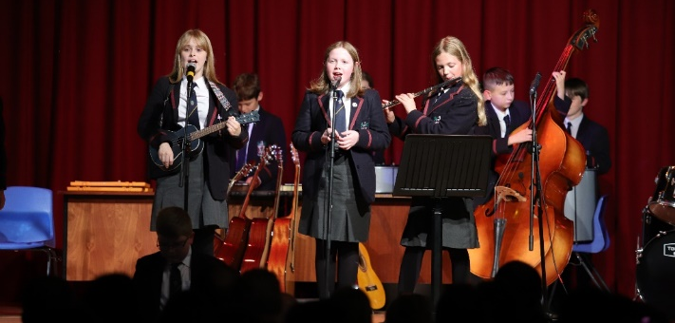

SECTION 8: EQUAL OPPORTUNITIES QUESTIONNAIRE
PLEASE CONTINUE TO SECTION 8
Office use only:
Ref: 2024/SpanishFrench/……….
This form will be detached from your application form and anonymised.

Please complete the following information by inserting an X in the appropriate box.

Gender

Female |  | Male

Community Background

I have a Protestant community background
I have a Roman Catholic community background
I have neither a Protestant nor a Roman Catholic community background

Disability

Disability is defined as a physical or mental impairment which has substantial and long term adverse effect on the individual’s ability to carry out normal day-to-day activities. Do you consider yourself you have a disability?

Yes |  | No

Race

Please indicate your racial origin by marking an X in the appropriate box

White |  | Chinese |  | Irish Traveller
Pakistan/Bangladeshi |  | Indian |  | Black Carribean
Black African |  | Other
If other, please specify

Sexual Orientation

Please indicate your sexual orientation by marking an X in the appropriate box

My sexual orientation is toward someone of the opposite sex.
My sexual orientation is toward someone of the same sex.
My sexual orientation is toward someone of the same sex and of the opposite sex.

Marital Status

Please indicate your marital status by marking an X in the appropriate box

Single |  | Married
In a civil partnership |  | Divorced
Formerly in a civil partnership now dissolved |  | Separated by still legally married
Separated but still legally in a civil partnership |  | Surviving partner from a civil partnership
Widowed

Dependents

Please indicate if you have a personal responsibility for the care of a child or children, a person with a disability, or a dependent older person.

Yes |  | No

